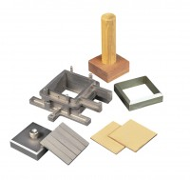 | Specimen Cutter 60mm Sq.  Code: 26-2185  Product Group: Shear Box Assemblies, Shear Box Assemblies

Standards
ASTM D3080, AASHTO T236

Spares/Consumables
Specimen Cutter 100mmsq.
Code: 26-2201
Specimen Cutter 2.5 Inch Diameter.
Code: 26-2217

