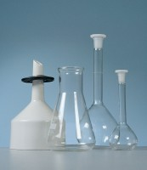 | Volumetric Flask - 500 ml  Code: 82-1040  Product Group: Funnels and Flasks  Soda glass, stoppered to BS ISO 1042 Class B.

Further Information
**NOT AVAILABLE FOR SALE IN THE USA**

