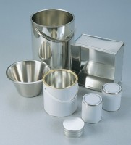 | Sample Container - Tinned Steel 2.5 litres  Code: 81-3040  Product Group: Moisture Content Tin and Sample Containers

Further Information
**NOT AVAILABLE FOR SALE IN THE USA**

