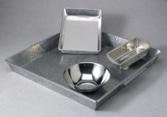 | Pan, Galvanized  Code: 88-7150  Product Group: Bitumen Extraction Test, Mixing Pans and Bowls  18" x 18" x 3" (450 x 450 x 76 mm)

