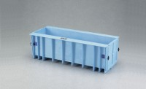 | Plastic Beam Form  Code: 34-5065  Product Group: Plastic Beam Form  For 6” x 6” x 21” (152 x 152 x 533 mm) samples.

Standards
ASTM C31, ASTM C78, ASTM C192, ASTM C293

Specification
Construction | Copolymer plastic
Weights | 10 lbs (4.53 kg)

