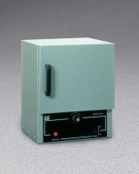 | Double Wall Laboratory Oven - 2.0 cu. Ft. Capacity - 115vAC  Code: 88-0210/02  Product Group: Double Wall Laboratory Ovens  115vAC, 50/60 Hz, 1ø.

Specification
Capacity | 2.0 cu. ft. (56.6 liter).
Chamber Size | 18â w. x 12 â d. x 16â h. (45 7 x 305 x 406 mm).
Temperature Range | 226 Â°C (43 7Â°F) maximum.
Shelves | Two included.
Thermometer | One included.
Overall Dimensions | 20â w. x 14 â d. x 25 â h.  (508 x 35 6 x 635 mm).
Weights | 70 lbs. (31 .8 kg).

