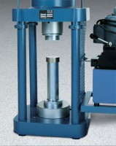 | Platen Set for 2" Cube  Code: 37-5514  Product Group: Accu-Tek 250 Series Cube Platen Sets, Accu-Tek Touch 250 Series

Standards
ASTM C109, ASTM C39, AASHTO T22

Specification
Construction | Precision ground and hardened steel; plated for rust and corrosion resistance.
Weights | Net 23 lbs. (10 kg).

