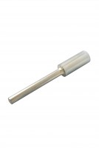 | Tamping Rod.  Code: 42-1720  Product Group: Particle Density (specific gravity) and Water Absorption for Fine Aggregates, Sand Absorption Cone and Tamper  For use with cone. Tamping face is 25mm diameter and complies with BS 812, ASTM C128 and AASHTO T84.

Standards
BS 812, ASTM C128, AASHTO T84

