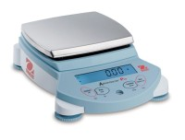 | Ohaus Electronic Balance - 24,000 g Capacity  Code: 88-1098/02  Product Group: Ohaus Series Electronic Balances  Includes automatic internal calibration and weigh-below hook.

Further Information
100-240V, 50/60 Hz.

