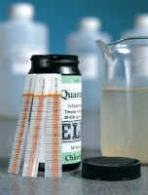 | Quantab Chloride Titrator Type 1175 Titration Range 0.005% - 0.1% 30-600ppm Nacl Pack of 40 Strips.  Code: 42-2950  Product Group: Chloride Content: Rapid Method  Type 1175 titration range 0.005% to 0.1% (30 to 600 ppm) NaCl. Pack of 50.

Further Information
**NOT AVAILABLE FOR SALE IN THE USA**

