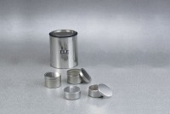 | Aluminium Moisture Cans - 2-1/2" Diameter  Code: 88-7004  Product Group: Aluminium Moisture Boxes  2-1/2" diam. x 1-3/4" h. (64 x 44 mm). Carton of 12.

Specification
Construction | Heavy-gauge aluminum.
Lid | Fits onto bottom as well as top of box.

