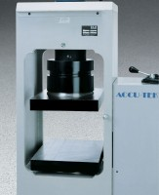 | Platen Set for Blocks up to 12"  Code: 37-5518  Product Group: Accu-Tek Touch 500 Series, Rapid-Change Block Platen Sets

Further Information
12" x 8" x 16" blocks max.

