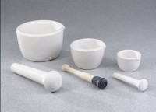 | Mortar & Pestle - 225 ml Capacity, 7" Length  Code: 88-6802  Product Group: Mortars and Pestles  Mortar 5-1/8” (130 mm) diam. x 2-3/4” (70 mm) h. 7” (178 mm) long pestle.

Specification
Material | Porcelain.
Weight | Net 6 lbs. (2.7 kg).

