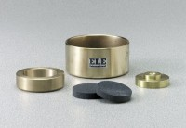 | 2.5" Floating Ring Consolidometer  Code: 25-0530  Product Group: Floating Ring Consolidometer, Pneumatic Consolidation Apparatus, Table Top Consolidation Apparatus

Specification
Specimen Size | 2.5â diam. x 1â h. (63.5 x 25 .4 mm).
Base | One-piece machined bronze; 5â diam. x 3â h.  (12 7 x 76.2 mm).
Specimen Ring | Machined brass.
Porous Stones | 2-15 /32 â diam. x 1/2â thick (62.7 x 12 .7 mm).
Weight | Net 13 lbs. (5.9 kg).

Spares/Consumables
Porous Stone 2-15/32" dia.
Code: 25-0530/10
Specimen Ring 2.5"
Code: 25-0533

