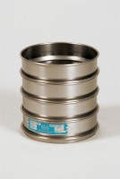 | 8in Dia ASTM Sieve 13.2mm Stainless Steel Mesh.  Code: 79-5540  Product Group: 8" Diameter ASTM Sieves, 8" Diameter ASTM Sieves, 8" Diameter ASTM Sieves

Standards
ASTM E11

Further Information
**NOT AVAILABLE FOR SALE IN THE USA**

