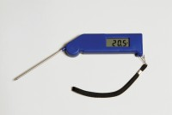 | Digital Pocket Thermometer  Code: 82-5420  Product Group: Digital Pocket Thermometer  The stainless steel probe carries a highly accurate platinum sensor and when not in use folds back into the side of the instrument. With a clear 8 mm high LCD display this instrument is powered by a standard 12 V MN21 battery or equivalent.

Further Information
**NOT AVAILABLE FOR SALE IN THE USA**

Specification
Dimensions (l x w x h) | 150 x 45 x 19 mm
Range | –49.9 to 199.9ºC
Resolution | 0.1ºC
Accuracy | ±0.4ºC
Weight | 105 g

