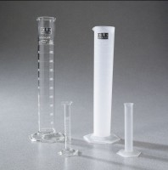 | Glass Graduated Cylinder - 50 ml Capacity  Code: 88-6004  Product Group: Glass Graduated Cylinders  50 ml capacity x 1 ml divisions.  Net Wt. 3 oz. (84 g).

Specification
Numbering | Double; with zero at top and bottom.
Packing | 1 cylinder/carton.

