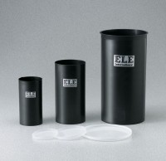 | Plastic Lid for 4" dia Mould  Code: 34-5292/10  Product Group: Plastic Cylinder Moulds  (102 mm) diam. Moulds. Carton of 50.

Standards
ASTM C39, ASTM C470, AASHTO M205

