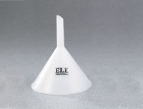 | Plastic Funnel - 4" top diam.  Code: 88-7202  Product Group: Plastic Funnels  4" (102 mm) top diam.; 3" (76 mm) stem.

Specification
Materials | Conventional polyethylene; non-toxic, non-contaminating; withstands nearly all chemicals at room temperature for 24 hrs.
Temperature Tolerances | 176Â°F (80Â°C) maximum; -148Â°F (-100Â°C) brittleness.

