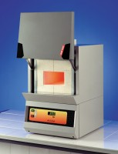 | Muffle Furnace  Code: 83-4170/01  Product Group: Loss-on-Ignition, Loss-on-Ignition, Furnaces

Standards
EN 196-2, EN 459-2, EN 13454-2, BS 1016-4, ISO 344, ISO 1171, ASTM D2361, ASTM D2795, ASTM D3714

Specification
External Dimensions (l x w x h) | 545 x 385 x 400 mm
Work chamber dimensions (l x w x h) | 300 x 200 x 120 mm
Internal volume | 6.9 litres
Maximum temperature | 1200 ºC
Electrical supply | 220 – 240 V AC, 50 - 60 Hz, 1 ph
Power supply | 3500 W
Weight | 130 kg

