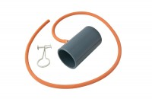 | Suction Membrane Device 38mm/1.5 Inch Diameter.  Code: 25-5100  Product Group: Suction Membrane Devices, Suction Membrane Device  Suction Membrane Device For 38Mm/1.5 Inch Samples.

