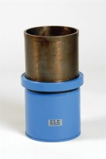 | 150mm Dia Cylinder Mould 300mm Long.  Code: 34-5260  Product Group: Cylinder Moulds  150 mm diameter x 300 mm long, complete with base plate and locking ring.

Further Information
**NOT AVAILABLE FOR SALE IN THE USA**

