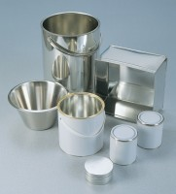 | Moisture Content Tin  Code: 81-2979  Product Group: Moisture Content Tin and Sample Containers

Further Information
**NOT AVAILABLE FOR SALE IN THE USA**

