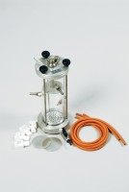 | Constant Head Permeability Cell 75mm Diameter Specimen.  Code: 25-0580  Product Group: Constant Head Apparatus  75 mm Diameter

Standards
BS 1377, EN 1997-2, ASTM D2434, AASHTO T215

Specification
Nominal Cell inside diameer | 75 mm
Cell wall | Transparent plastic
Take-off points | 3
End plates | Anodised aluminium
Weight kg | 2.6

