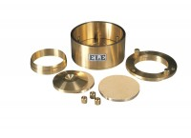 | Upper and Lower Porous Stones, 2.416"  Code: 25-0480/13  Product Group: Fixed Ring Consolidation

Standards
ASTM D2435, ASTM D4546, AASHTO T216

