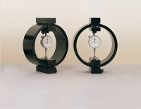 | Clamped Boss Load Ring - 2.0 kN  Code: 78-0060  Product Group: Clamped Boss Load Rings, Digital Tritest 50 Load Frame, Direct/Residual Shear Apparatus, Proving Rings, Force measurement, Measurement of Load (Shear Stress)

Standards
BS 1377, ASTM D3080

Specification
Capacity: kN, kgf, lbf | 2.0, 200, 450
Typical Design sensitivity: N/div, kgf/div, lbf/div | 1.3, 0.13, 0.30
Overall height mm | 248
Approx weight kg | 3.2
Capacity | 2 kN
Value of CBR | Up to 8%
Capacity - lbf | 450
Capacity - kN | 2
Capacity - kgf | 200
Typical Design Sensitivity - lbf/div | 0.3
Typical Design Sensitivity - kN/div | 1.3
Typical Design Sensitivity - Kgf/div | 0.13
Overall Height | 9.76” (248 mm)
Approx Weight | 7 lbs. (3.2 kg)

Spares/Consumables
 | Spare Dial Indicator for Load Rings  Code: 78-5461

