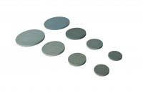 | 4.0" Porous Stones  Code: 25-7761  Product Group: Porous Stones, Tri-Flex 2 Permeability Test Cell  4" diameter porous stones (pack of 2)

Standards
ASTM D2850, ASTM D4767, ASTM D5084, AASHTO T296, AASHTO T297, ASTM D7181

