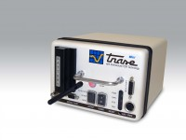 | Minitrase Kit with Bluetooth and Android  Code: 514-190/01  Product Group: TDR

