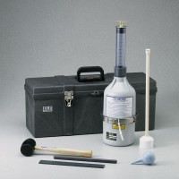 | Volumetair  Code: 34-3272  Product Group: Volumetair

Standards
ASTM C173

Specification
Sight tube | 0 to 9%
Base volume | 134 cu. Ft (2,200 ml)
Diameter | 7.25" (184 mm) at middle
Height | 24.25" (616 mm)
Weight | Net 6 lbs (2.7 kg)

Spares/Consumables
 | Concrete Air Indicator  Code: 38-3280/10

