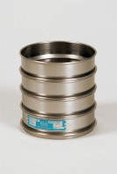 | 200mm Dia BS Sieve 53 Mic Stainless Steel Mesh.  Code: 79-0060  Product Group: 200mm Diameter BS Sieves, 200mm Diameter BS Sieves, 200mm Diameter BS Sieves

Standards
BS 410, ISO 3310

Further Information
**NOT AVAILABLE FOR SALE IN THE USA**

