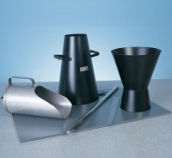 | Slump Cone Funnel  Code: 34-0180  Product Group: Slump Cones, Portable Slump Test Set, Slump Test Set, Slump Test

Standards
ASTM C143, ASTM C192, AASHTO T23, AASHTO T119, ASTM T126

