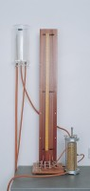 | Constant Level Tank.  Code: 25-0593  Product Group: Constant Head Apparatus  Manufactured from transparent plastic with attachment for wall mounting. The inlet, outlet and overflow pipes are fitted to the base  of the tank and can be adjusted for height within the tank. Supplied complete with connecting tubing.

Standards
BS 1377, EN 1997-2, ASTM D2434, AASHTO T215

