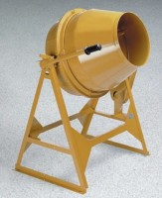 | Laboratory Concrete Mixer  Code: 34-3592/02  Product Group: Laboratory Concrete Mixer  Electric motor and hand tow kit included.

Further Information
110vAC, 60 Hz, 1ø.

Specification
Mixing Capacity | 3 cu. Ft. (85 litres)
Drum Capacity | 5-1/2 cu. Ft. (156 litres)
Motor | 1/3 h.p
Dimensions | 41" l x 26" w x 55" h (1041 x 660 x 1,397)
Weight | Shpg. 300 lbs (145 kg)

