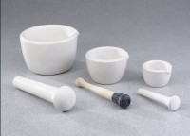 | Soil Pestle  Code: 88-6812  Product Group: Soil Mortar and Pestle

Specification
Mortar | Porcelain; glazed outside; 5â diam. x 2-1/2â h. (127 x 64 mm).
Pestle | Rubber tip with wood handle;  8â (203 mm) long.
Weight | Net 8 oz. (227 g).

