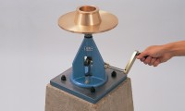 | Flow Mould  Code: 38-6040  Product Group: 10" Flow Table, Flow and Workability of Mortar Lime  Manufactured from bronze as specified in BS and ASTM.

Standards
ASTM C230

