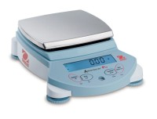 | Ohaus Electronic Balance - 310 g Capacity  Code: 88-1024/02  Product Group: Ohaus Series Electronic Balances  Includes weigh-below hook.

Further Information
100-240V, 50/60 Hz.

Specification
Maximum Capacity | 310 g
Readability | 0.001 g
Repeatability (Std. Dev.) | 0.001 g
Linearity | +/-0.002g
Internal Calibration | NO
Pan Size (in/cm) | 4.7 / 12
Dimensions w x h x d (in/cm) | 8.7â x 7.5â x 11 .8â  / 22 x 19 x 30  (with draft shield)
Shipping Wt. (lb/kg) | 13 .7 / 6.6

