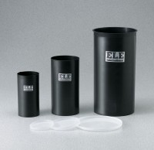 | Plastic Lid for 3" dia Mould  Code: 34-5290/10  Product Group: Plastic Cylinder Moulds  (76 mm) diam. Moulds Carton of 50

Standards
ASTM C39, ASTM C470, AASHTO M205

