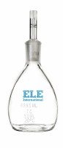 | Glass Specific Gravity Bottle - 50 ml Capacity  Code: 88-6302  Product Group: Glass Specific Gravity Bottles

