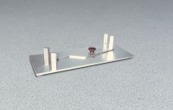 | Proportional Caliper Device  Code: 42-0405  Product Group: Proportional Caliper Device

Standards
ASTM D4791

Specification
Mold | Steel, plated for corrosion resistance.
Pivot Ratios | Stamped on plate. 2=1:2, 3=1:3, 4=1:4  and 5=1:5
Weight | Net 7 lbs. (3.2 kg).

