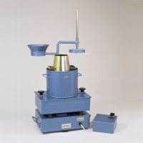 | Vibro Consistometer  Code: 34-0300/01  Product Group: Vebe Time  Comprising of vibrating table, container, slump cone, graduated rod and plate. For 220 - 240 V AC, 50 Hz, 1 ph.

Further Information
**NOT AVAILABLE FOR SALE IN THE USA**

