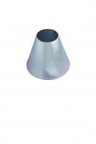 | Sand Absorption Cone.  Code: 42-1700  Product Group: Particle Density (specific gravity) and Water Absorption for Fine Aggregates, Sand Absorption Cone and Tamper  Made of brass to the dimensions given in BS 812, ASTM C128 and AASHTO T84.

Standards
BS 812, ASTM C128, AASHTO T84

