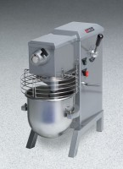 | Standard Bench Mixer  Code: 88-3000/02  Product Group: Standard Bench Mixers  115vAC, 60Hz, 1ø.

Specification
Capacity | 15 qt. (14 .2 liter) bowl. Actual sample capacity is lower and varies based on consistency and material type being mixed.
Motor | 1/3 hp.
Controls | Momentary contact STOP and START buttons and contactor.
Speeds | 4-locked in speeds of 125 , 180, 24 0 and 300 rpm; plus any in-between speed.
Dimensions | 13 -3/4â w. x 25 -3/8â d. x 28-1/4â h. (349 x 644 x 717 mm).
Weight | Net 14 6 lbs. (66 kg); Shpg. 170 lbs. (77 kg).

