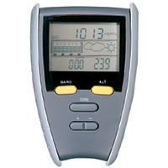 | Pocket altimeter  Code: 500-112  Product Group: Surveying Equipment  With combination holder, as specified.

