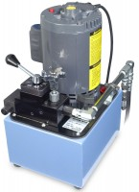 | Electric Pump Attachment 220vAC  Code: 37-5574/06  Product Group: Electric Pump Attachment

Further Information
220vAC, 60 Hz, 1ø.

Specification
Motor | 2 h.p. (0.7 kw).
Flow Control Valve | Pressure compensated system; regulates variable flow and relieves excess delivery back into reservoir
Hydraulic Fluid/Delivery | Variable; from 2 cu. in./min. to maximum pump  capacity.
Normal Operating Pressure | Swivel seat type; 6-1/4â (15 9 mm) diameter.
Weight | Net 80 lbs. (36 kg).

Spares/Consumables
 | Accutek Oil  Code: 9806-0016

