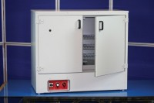 | 425 Litre Drying Oven  Code: 78-0135/01  Product Group: Oven Drying Method, Oven Drying Method, Oven Drying Method

Standards
EN 12697-32, EN 13280-4, BS 598-104, BS 1377

Specification
Capacity | 425 litres
External Dimensions (l x w x h) | 790 x 1350 x 670 mm
Internal Dimensions (l x w x h) | 640 x 920 x 760 mm
Fluctuation | ± 0.75°C
Rated power heater elements | 2000 W
Shelves supplied | 4
Shelf positions | 5
Weight | 120 kg

