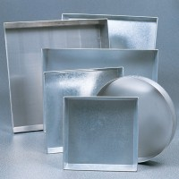 | Sample Tray - 406 x 406 x 50 mm  Code: 81-4030  Product Group: Sample Trays

Further Information
**NOT AVAILABLE FOR SALE IN THE USA**

