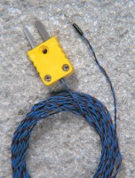 | Thermocouple Wire  Code: 82-5440/10  Product Group: Hand-held Digital Thermometers  Accessory. 3 metre length, suitable for 82-5440 Digital Thermometer.  The thermocouple is NiCr/NiAi PTFE covered with a naked exposed junction. Supplied with a coupling unit the maximum reading is 250ºC with a tip diameter of 0.5 mm. (Pack of 5).

Further Information
**NOT AVAILABLE FOR SALE IN THE USA**

