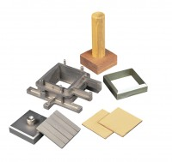 | Porous Plate 100mm Sq.  Code: 26-2197/10  Product Group: Shear Box Assemblies

Standards
ASTM D3080, AASHTO T236

