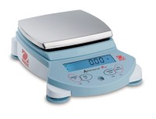 | Ohaus Electronic Balance - 6,000 g Capacity  Code: 88-1074/02  Product Group: Ohaus Series Electronic Balances

Further Information
100-240V, 50/60 Hz.

Specification
Maximum Capacity | 6,000 g
Readability | 0.1 g
Repeatability (Std. Dev.) | 0.15 g
Linearity | +/-0.4g
Internal Calibration | NO
Pan Size (in/cm) | 7.9 x 9.5 in / 200 x 24 0 cm
Dimensions w x h x d (in/cm) | 10.5 x 13 .2 x 4 in  / 26.5 x 33 .5  x 10 cm
Shipping Wt. (lb/kg) | 12 lb / 5.1  kg

