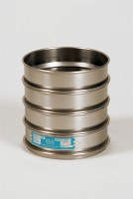 | 12in Dia ASTM Sieve 125mm Stainless Steel Mesh. Non Standard Frame.  Code: 79-6400  Product Group: 12" Diameter ASTM Sieves, 12" Diameter ASTM Sieves, 12" Diameter ASTM Sieves

Standards
ASTM E11

Further Information
**NOT AVAILABLE FOR SALE IN THE USA**

